**JAVA**

Java is a programming language and computing platform first released by Sun Microsystems in 1995.

When we create java programs and compile them class files will be created. These class files contain byte code.

Java contains three things mainly.

JVM – Java Virtual Machine

JRE – Java Runtime Environment

JDK – Java Development Kit

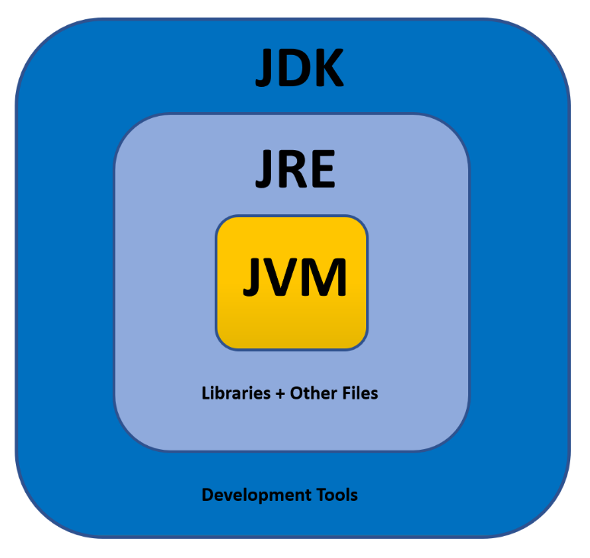

JVM (Java Virtual Machine):

The JVM performs following main tasks:  
Loads code  
Verifies code  
Executes code

JRE (Java Runtime Environment):

JRE is used to provide runtime environment. It contains set of libraries + other files JVM uses at runtime.

JDK (Java Development Kit):

JDK is java development kit. It contains JRE + development tools.

JDK, JRE and JVM are all platform dependent. But java is platform independent.

JVM Architecture:

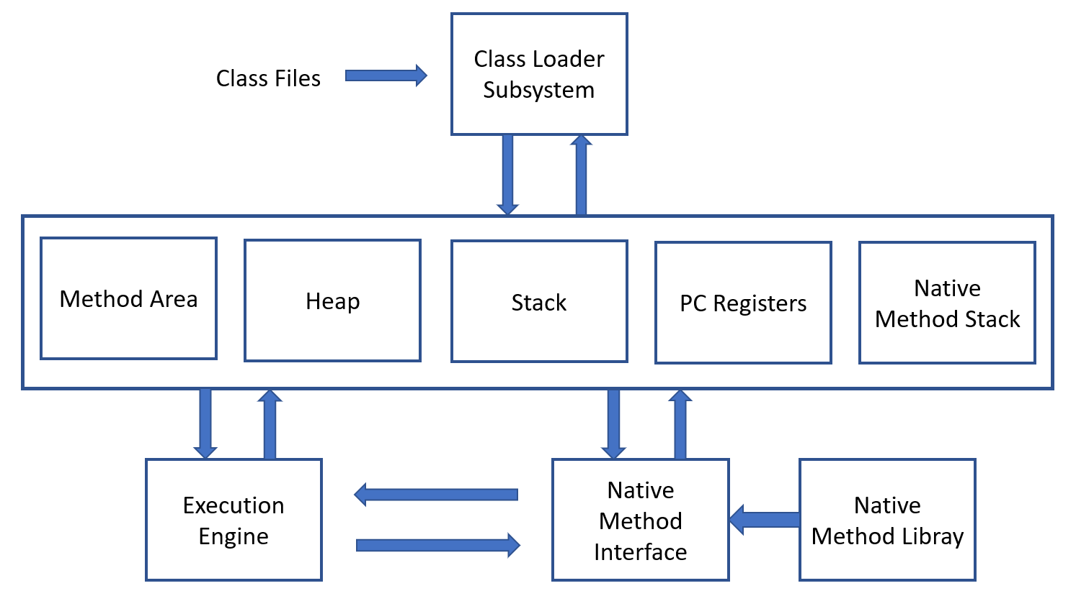

The class Loader Subsystem takes a class file as input and perform the following operation.

Method Area: It stores all the class code, method code and class variables declared.

Heap Memory: It stores all the objects created.

JVM stack Area: It stores the information of methods at run time. For example, the method variables initiated at run time.

PC Registers: It stores the address of next information that has to be executed.

Java Native Stack: It store Non Java coding available in java code. Ex: Comments

Execution Engine: It is responsible for executing the program.

**Starting with JAVA:**

**Installing Java JDK:**

Go to google and search “Java JDK download”.

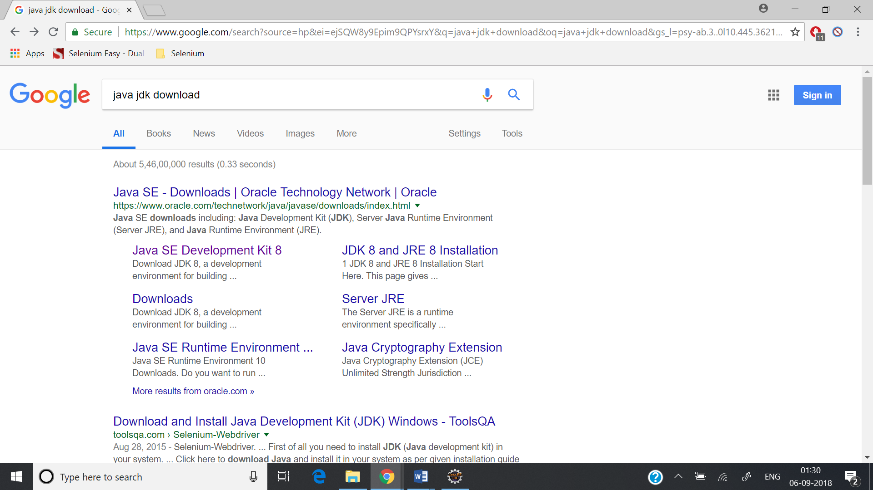

Click on the first link.

Download JDK 8 Version.

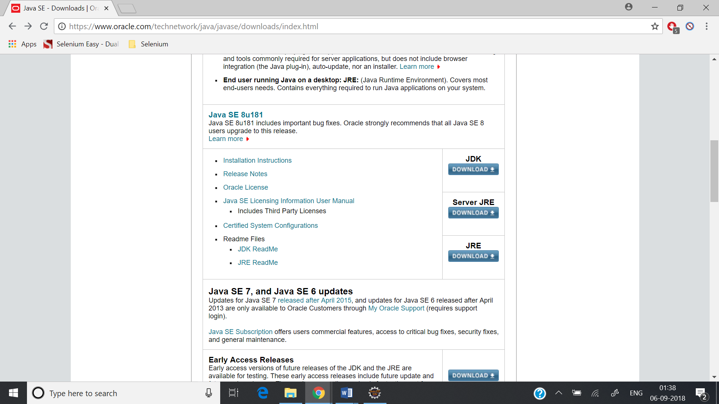

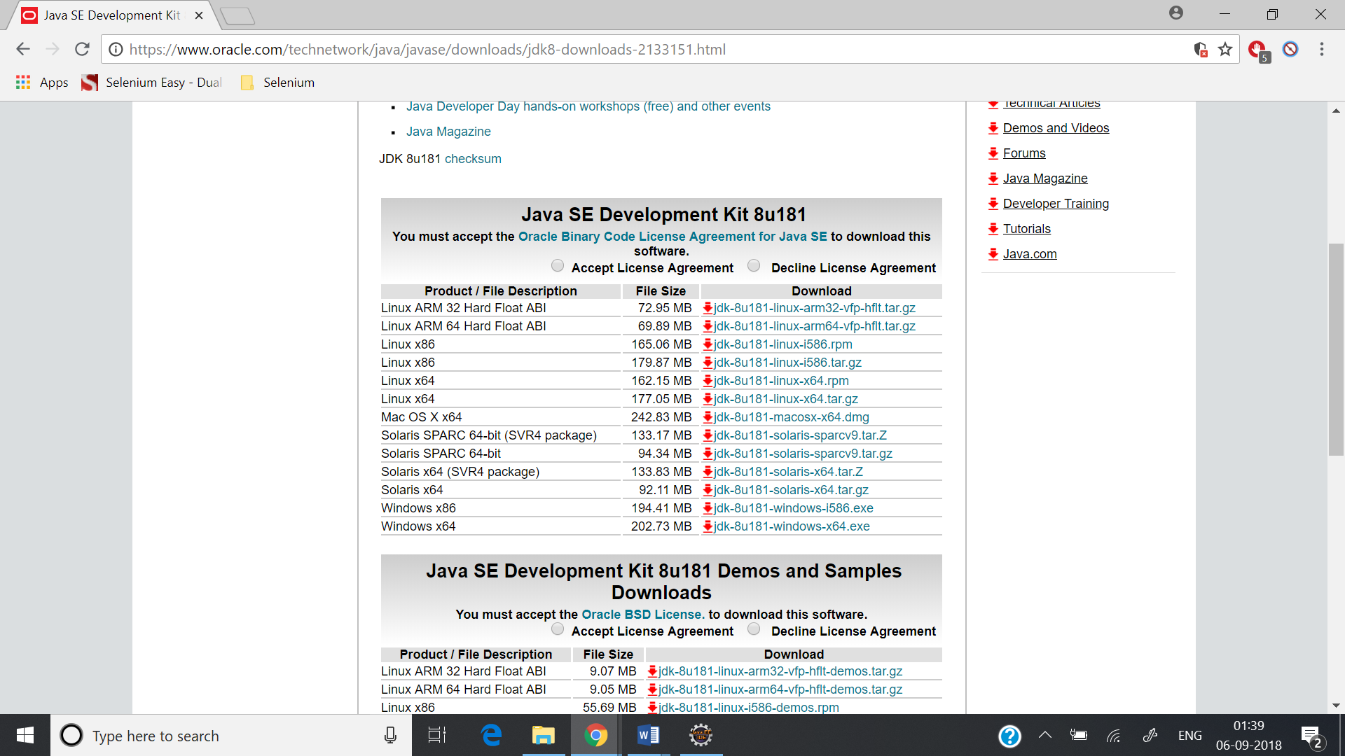

Download the corresponding version as per your operating system and install it.

Once installation is completed check where the JDK is installed. To check this go to

C Drive -> Program Files

If Java folder is there, go to that folder and check if JDK is present.

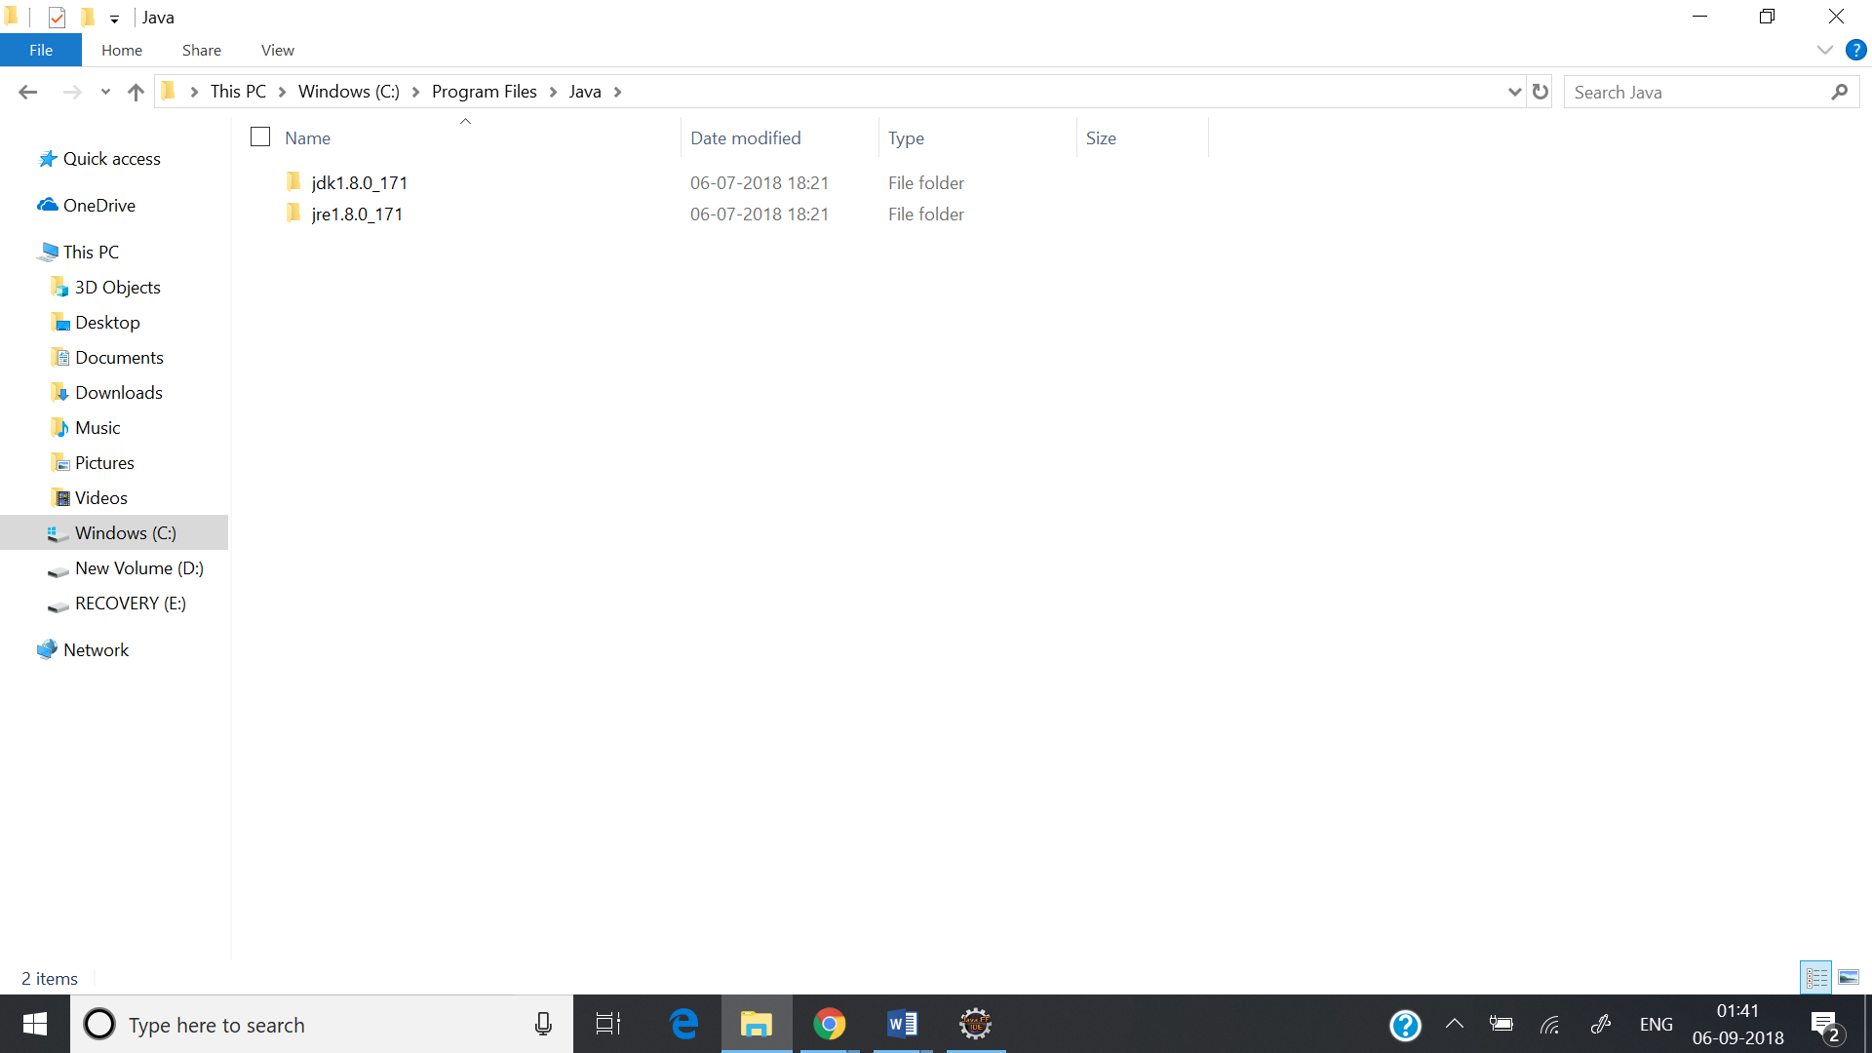

**Configure Java Path in System Variables:**

Right click on “This PC” and go to “Advanced System Settings”

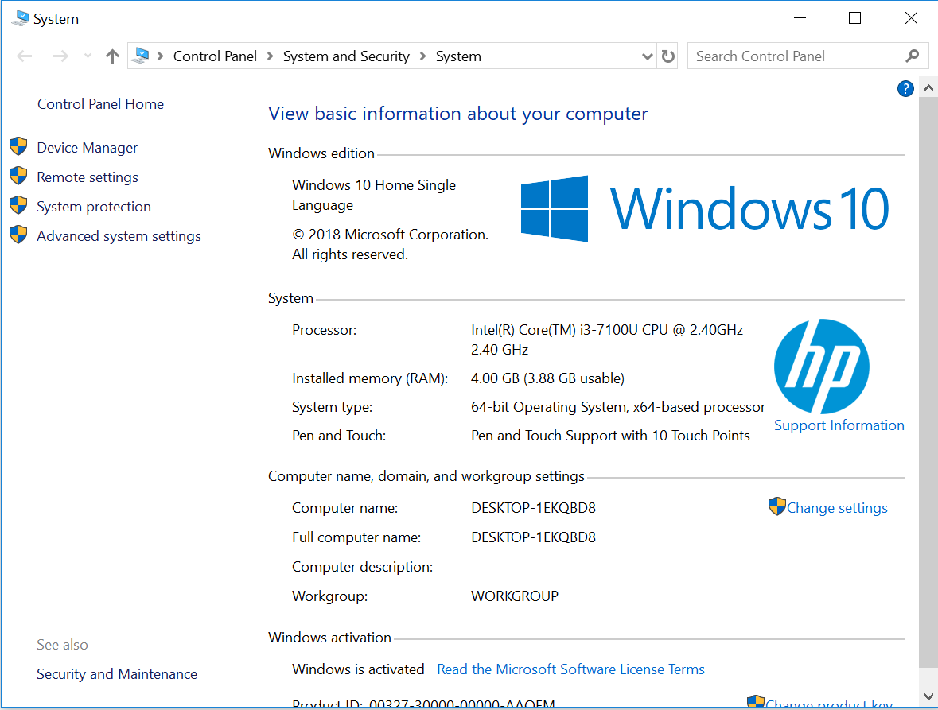

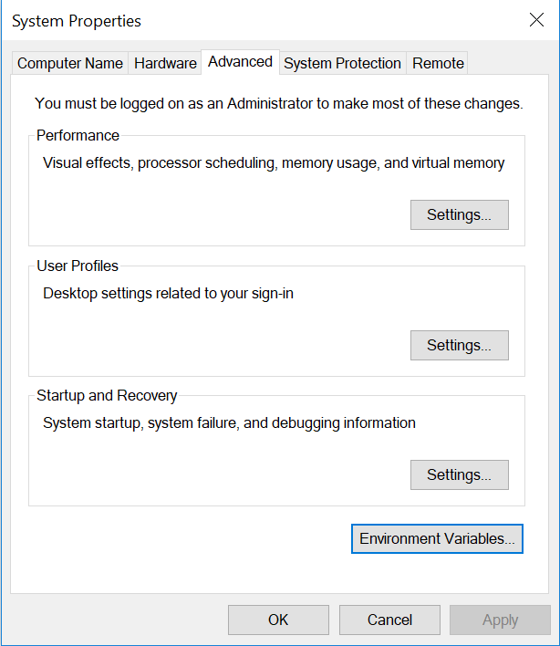

Go to Environment Variables. 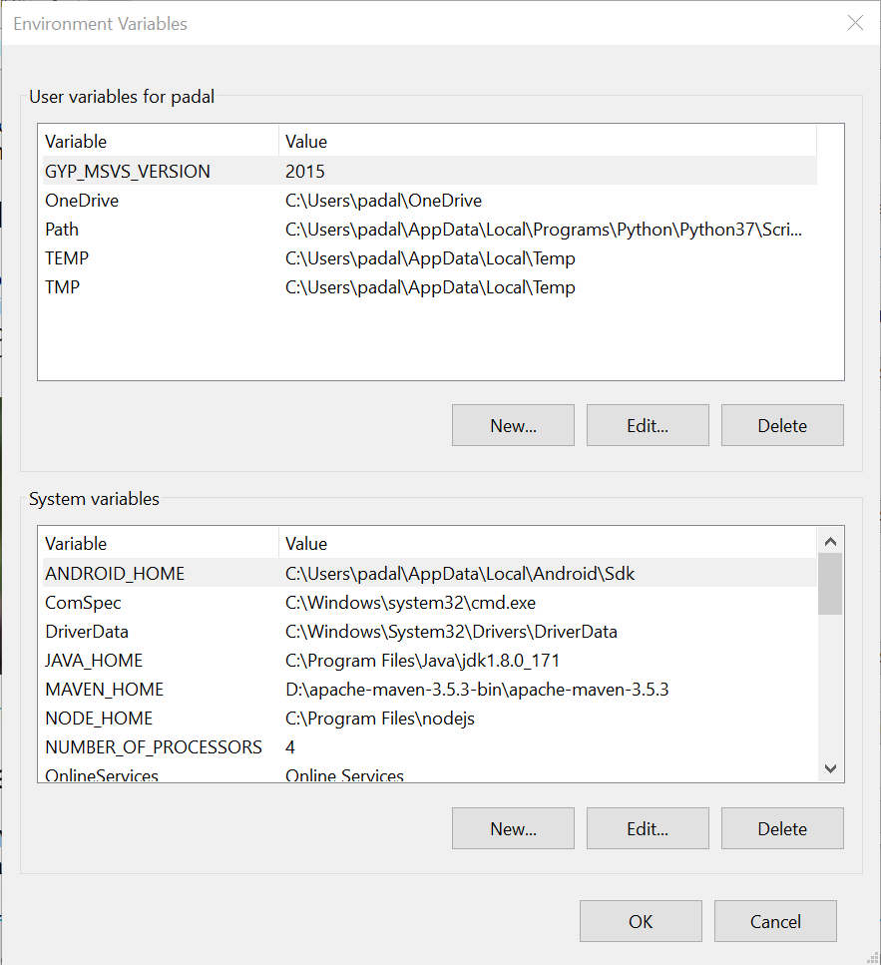

System Variables is the section where you have to add the paths.

There are two paths you have to have.

JAVA_HOME – your jdk directory. (C:\Program Files\Java\jdk1.8.0_171)

Path – Your bin folder in jdk directory. (C:\Program Files\Java\jdk1.8.0_171\bin)

Click on New and add the JAVA_HOME Variable.

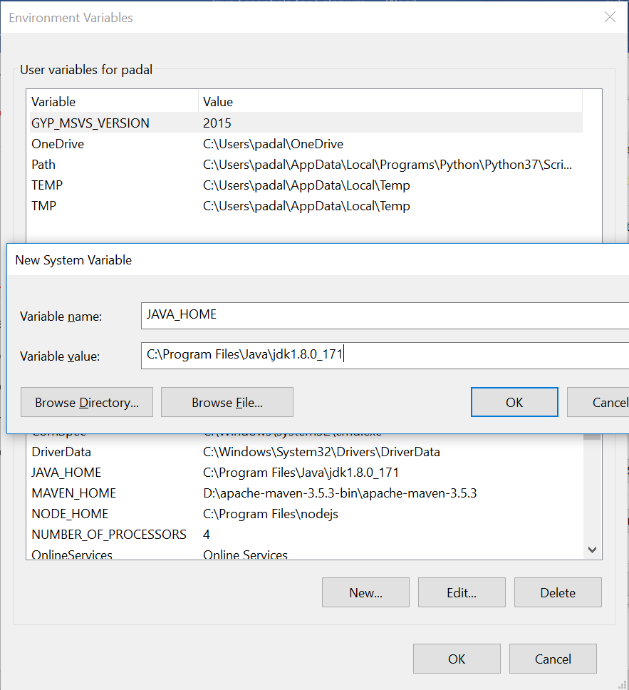

Path variable should already be there. Edit it and add the path to the bin directory.

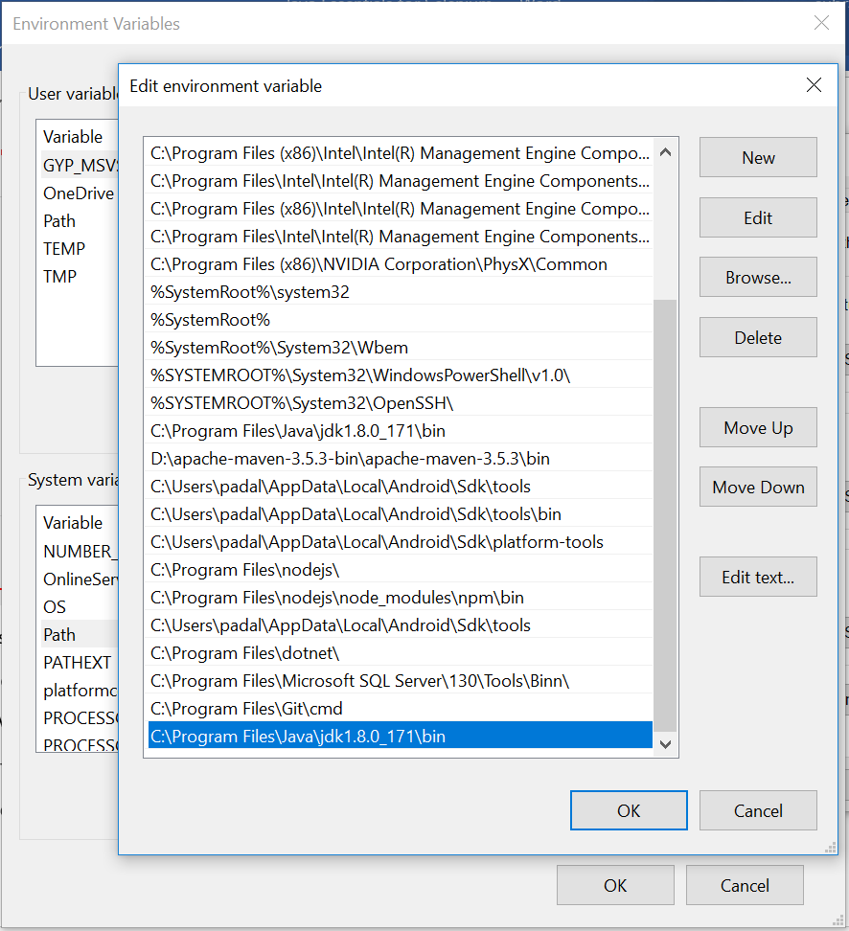

To check if java is set up correctly in your system, go to command prompt and type the command “java -version” and it should show the version.

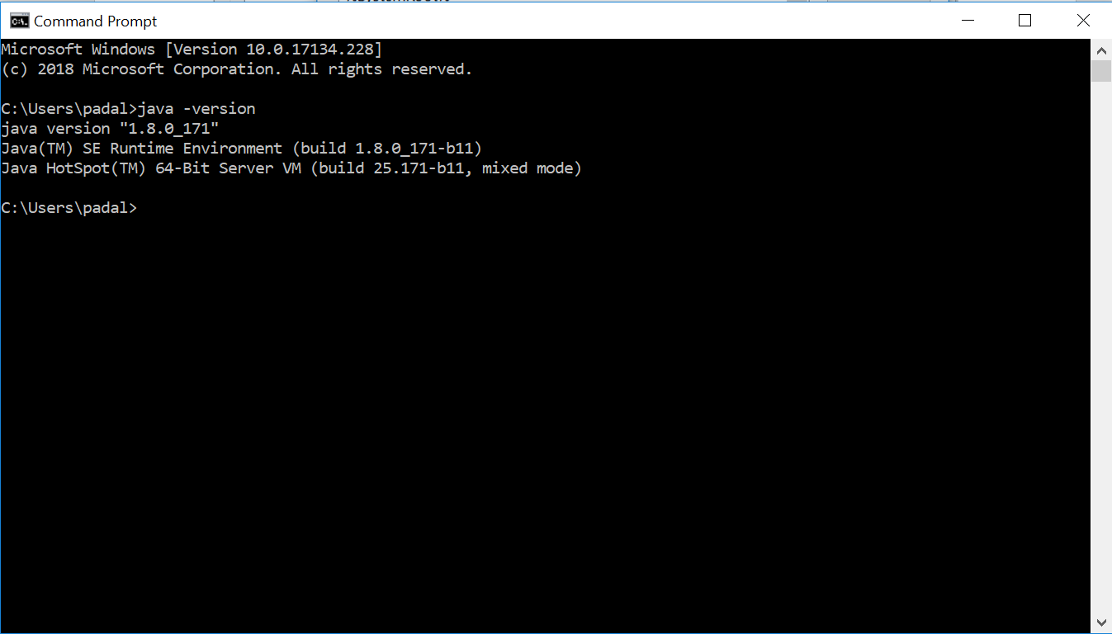

**Eclipse Installation:**

Go to google and type “Eclipse Download”

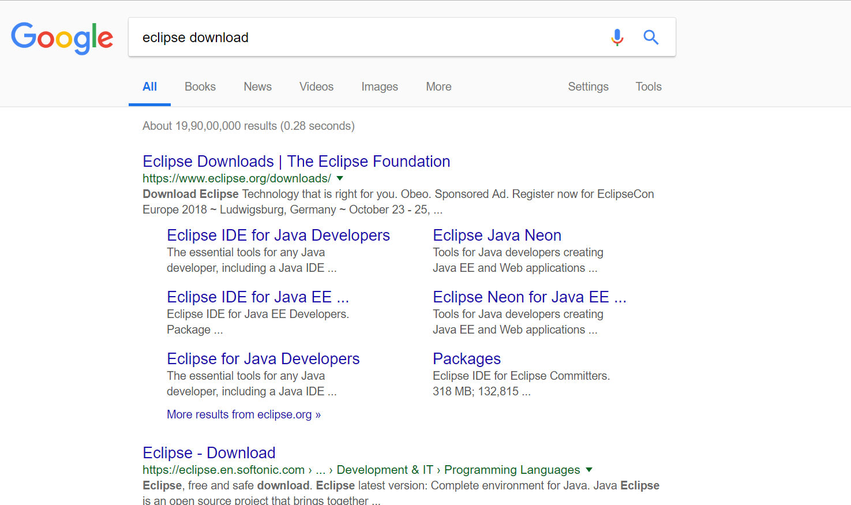

Go to the eclipse downloads and packages.

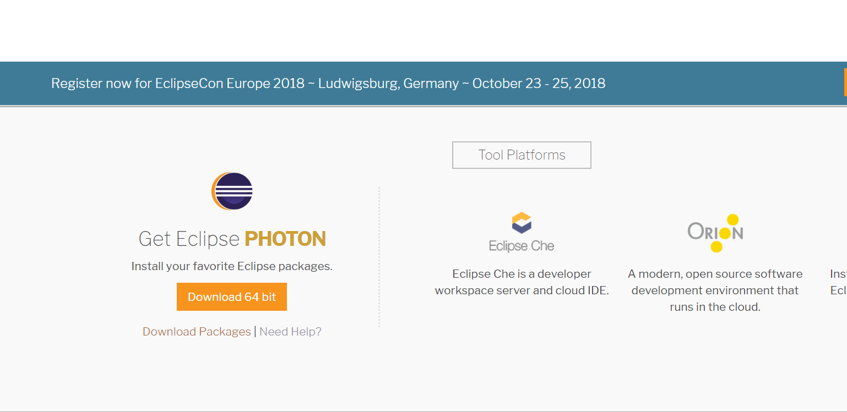

Go to download packages.

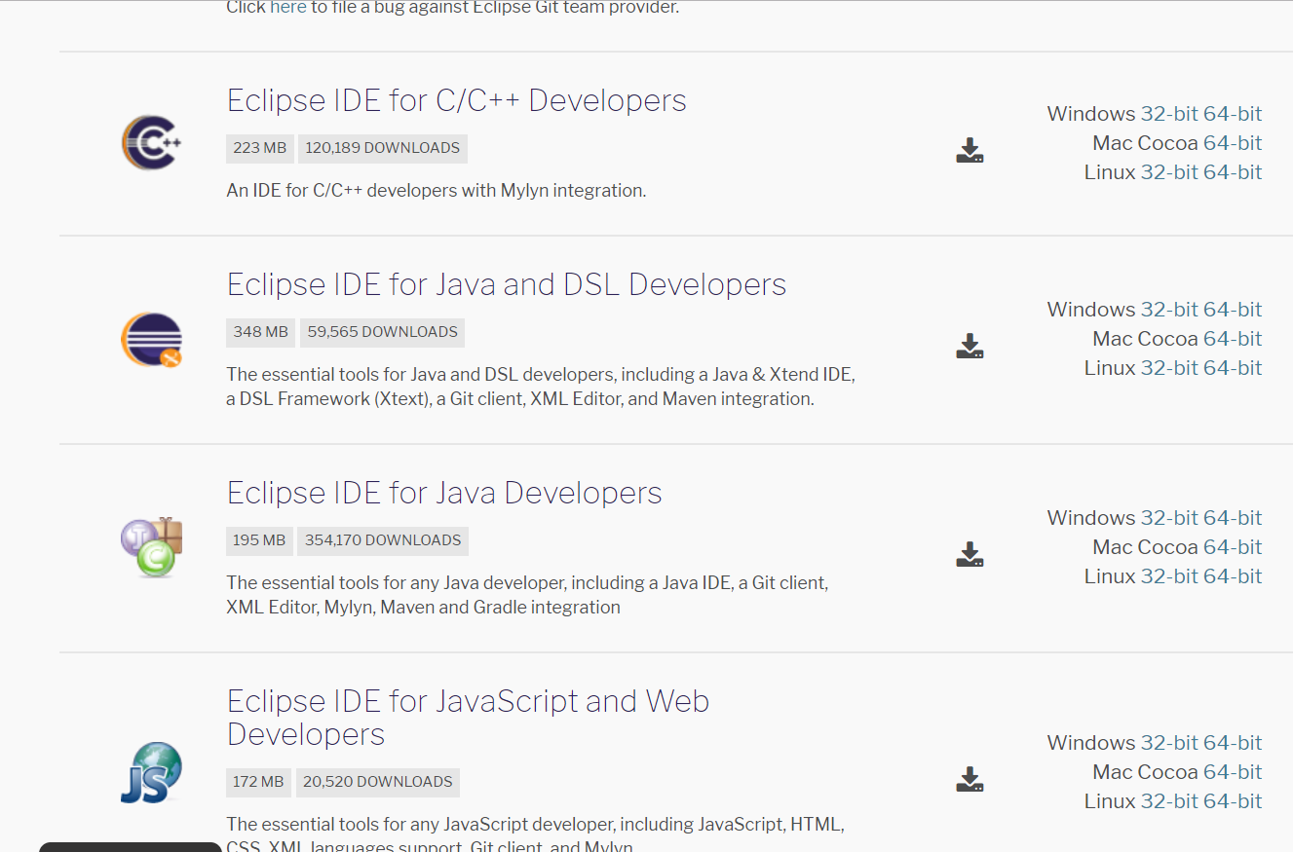

Download “Eclipse IDE for Java Developers”

Once Eclipse is downloaded, unzip it and go to the eclipse folder.

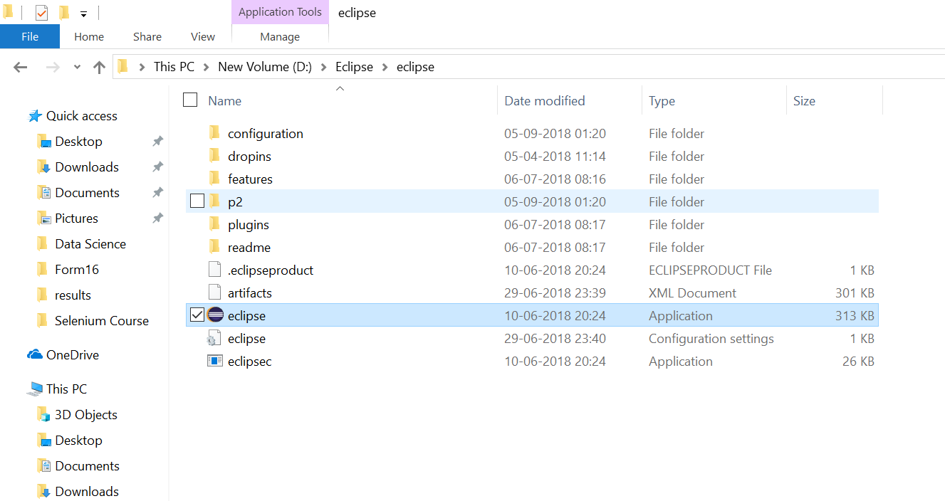

Click on Eclipse application link. It will ask you for the workspace. Provide a workspace folder and you are ready to start with your selenium scripts.

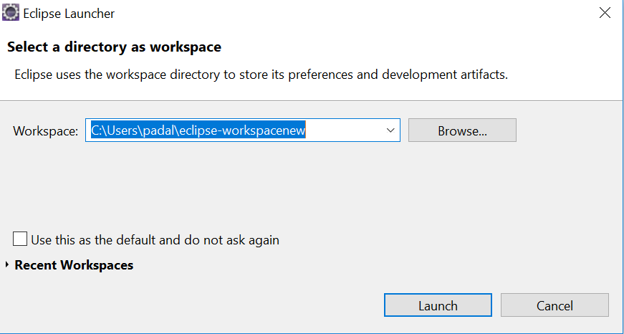

The first screen you see:

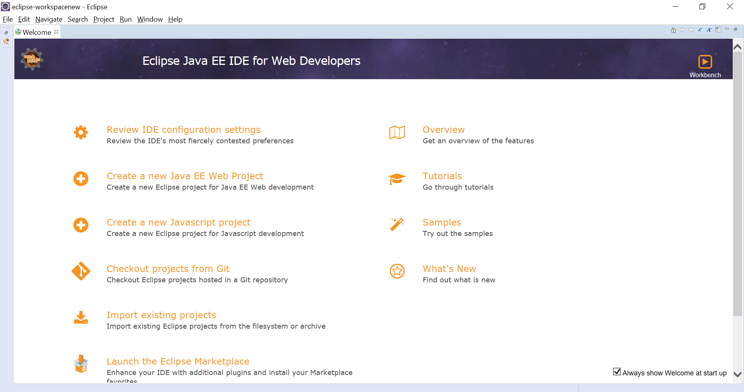

Click on Workbench:

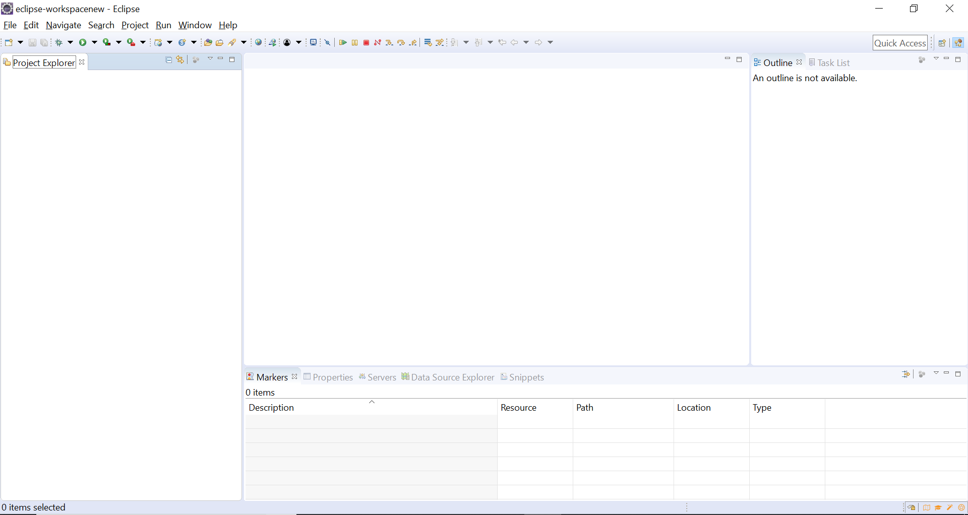

**Creating a Project:**

Go to File -> New -> Project

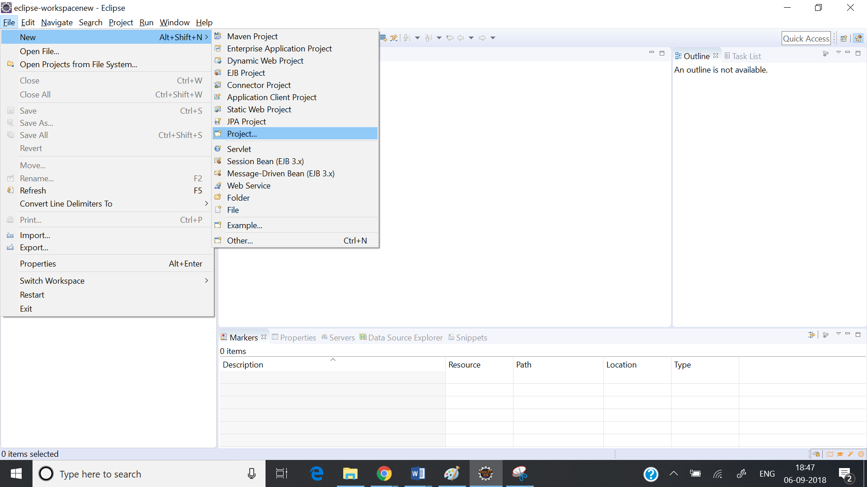

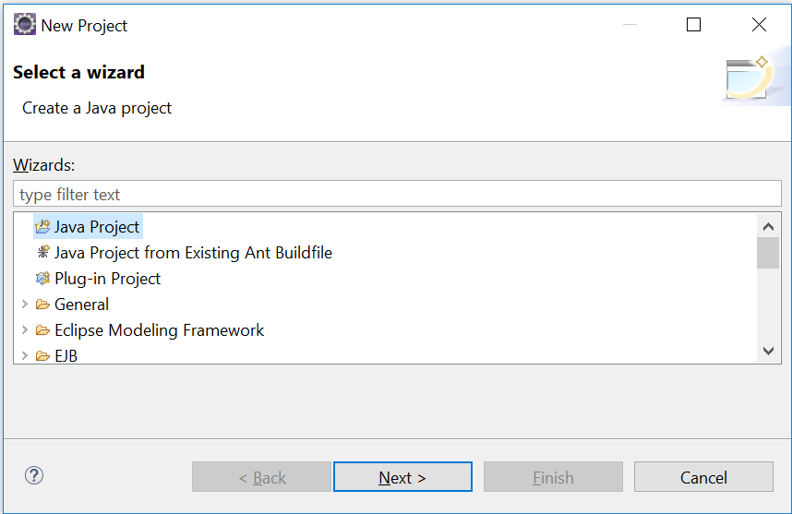

Select Java Project.

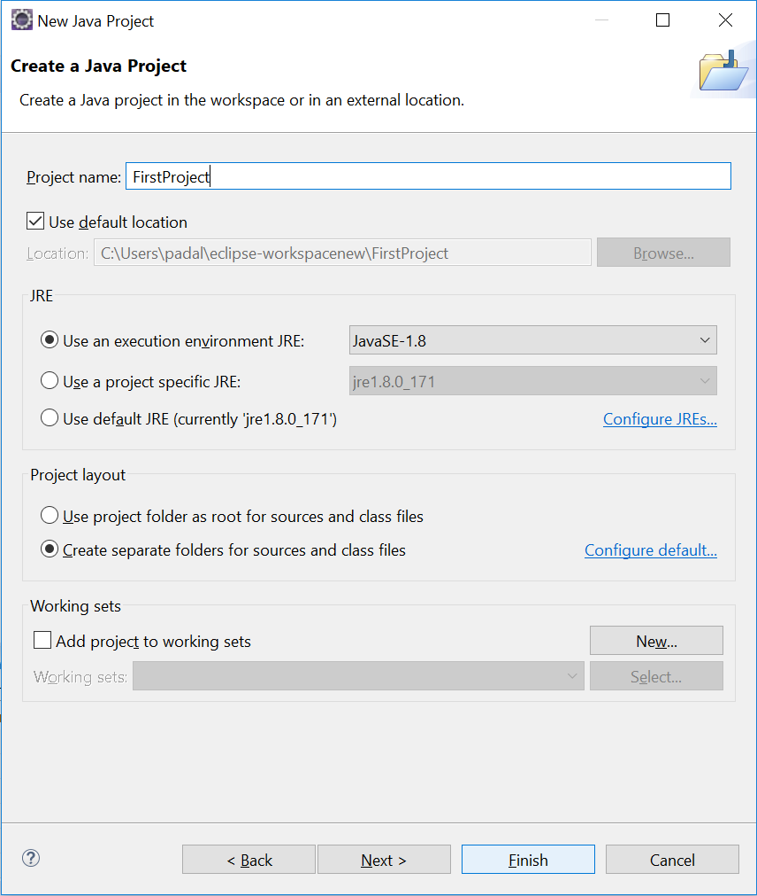

Give a name to the project and click on Finish.

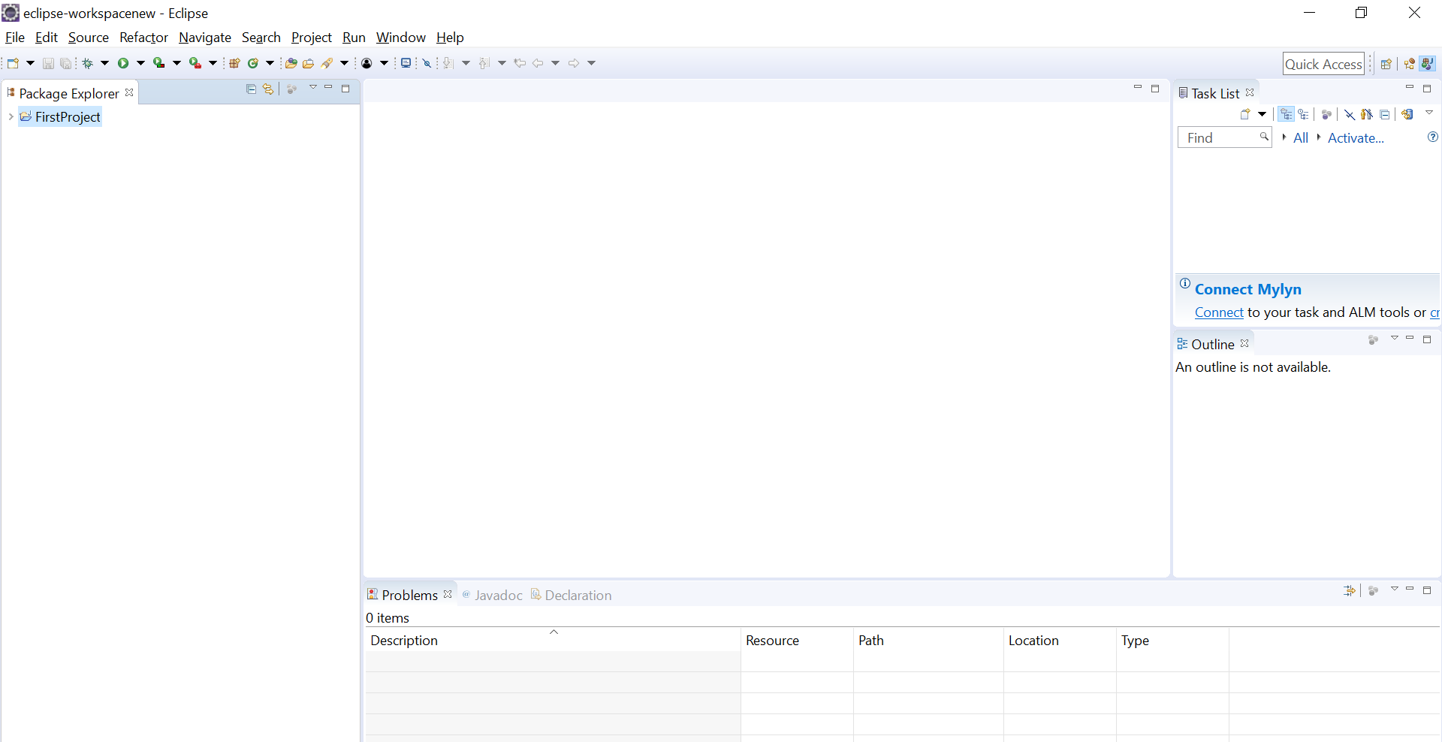

A new project with the name “First Project” is created.

**Creating a program (java file) under project:**

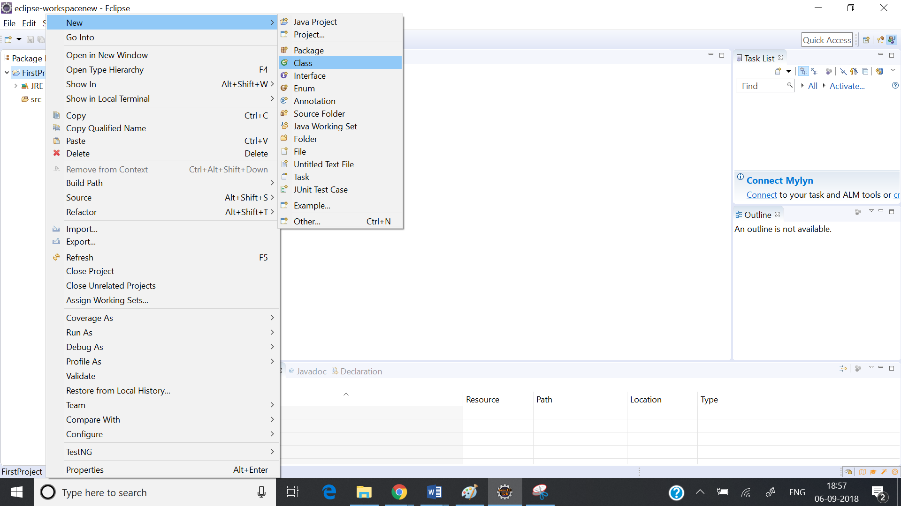

Right click on the project click on “New” and click on “Class”.

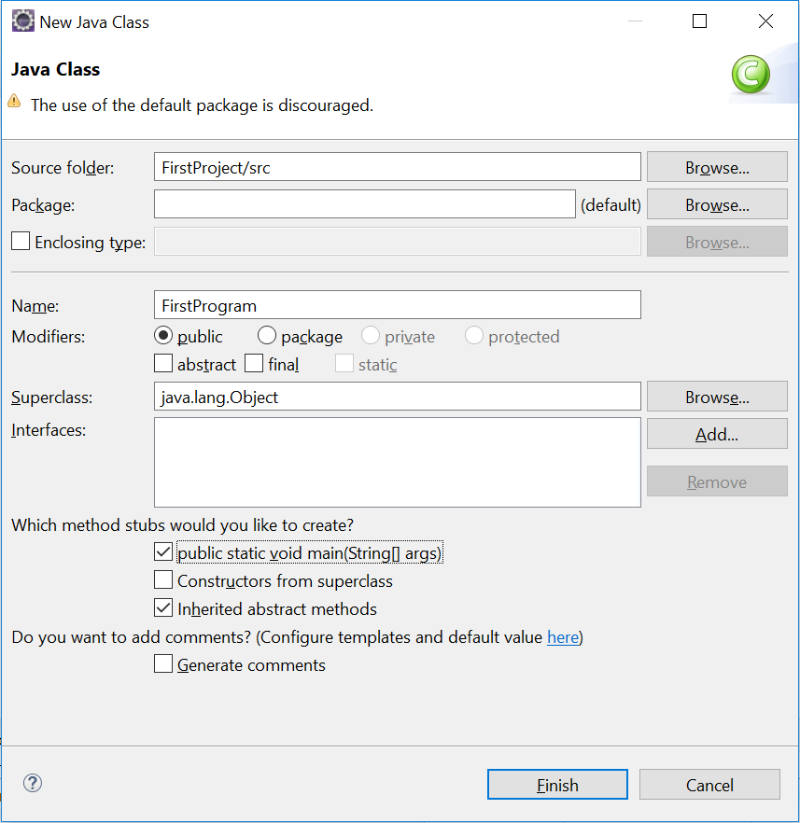Give a name like “FirstProgram” and click on Finish.

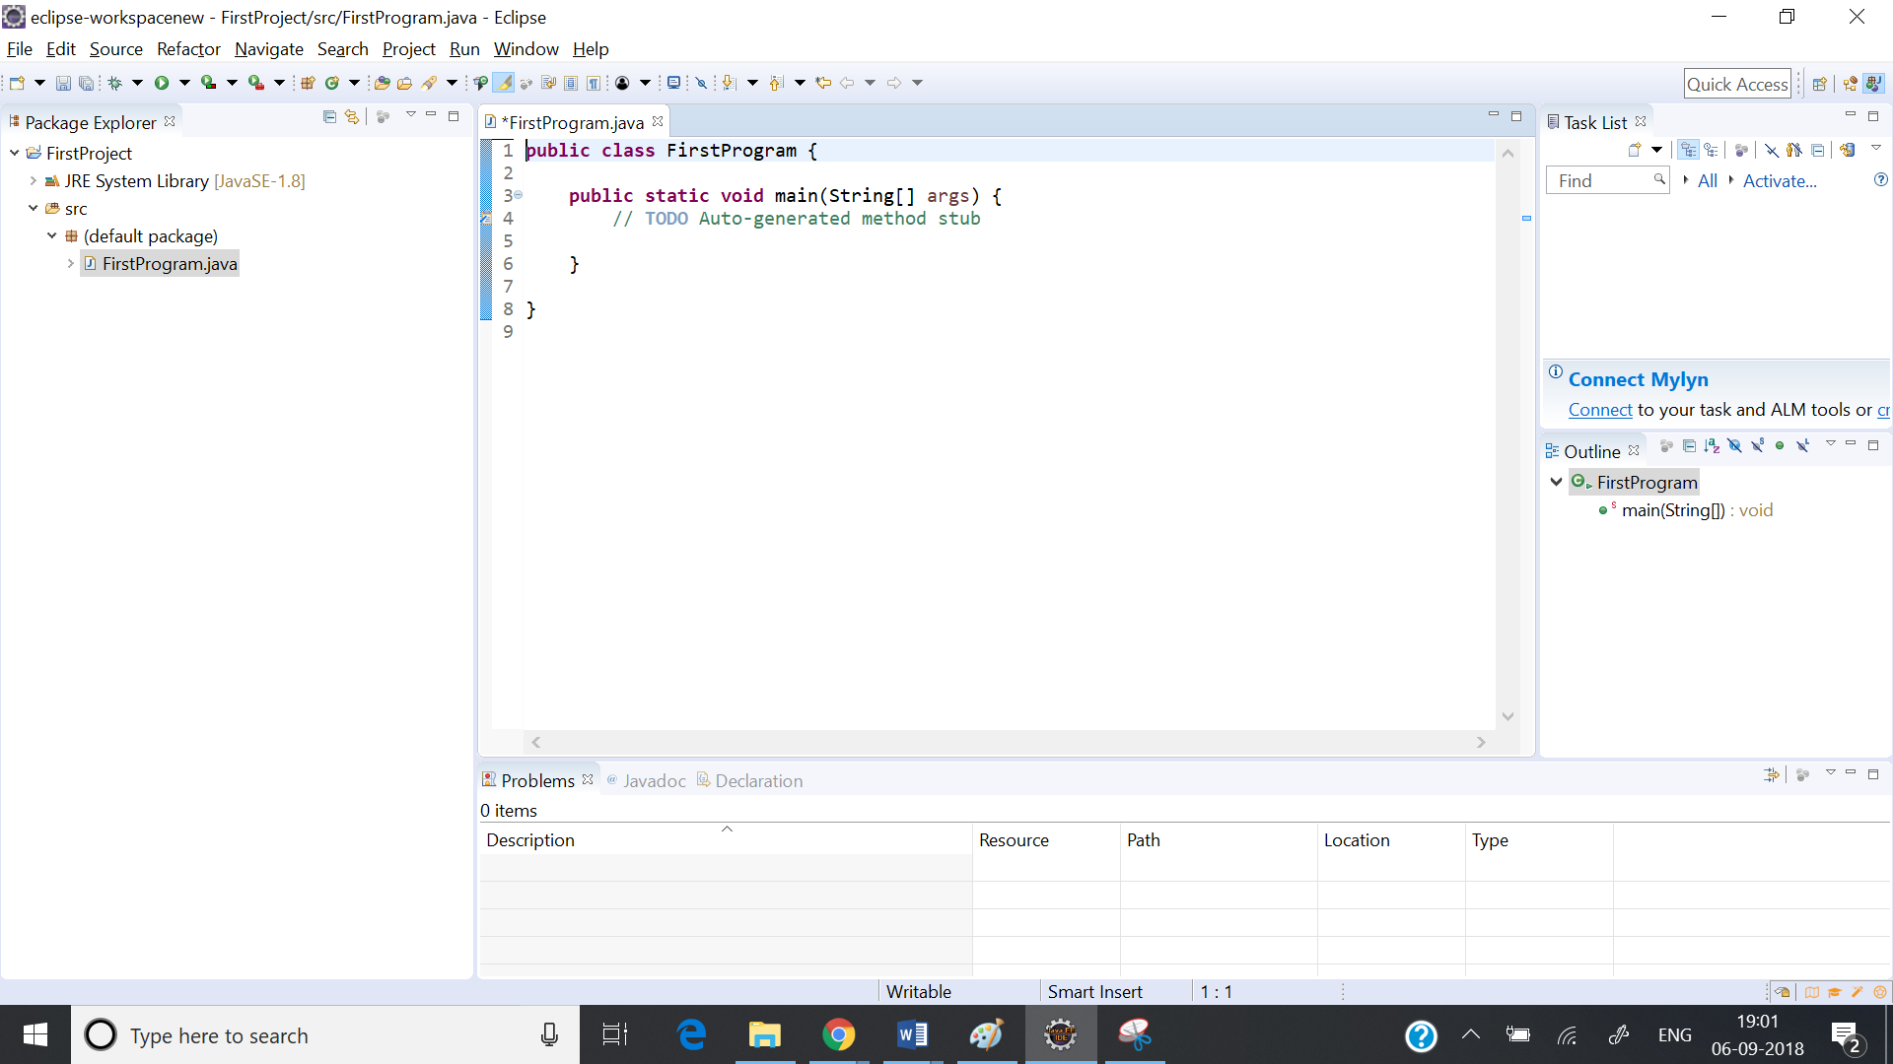

This will create a program template and you can add your code to it.